Suzanna Wentzel - s1850512 Milo Cesar - s1829688  
Jesper Simon - s1820338 Danique Lummen - s1853155  
Chris Witteveen - s1847821 Apostolis Christoulias - s1833383

**Design Report**

31 October 2016

**1. Problem Definition**

**1.1 Problem Scope**

In care centre “Liemerije”, clients and nursing staff have trouble with getting into different rooms with different keys. Finding the right key for a certain door takes time which in the case of the nursing staff can be better spent in helping the clients. The finding of the keys and the opening of the doors in the way used now is very inconvenient and thus this is a problem that needs to be solved.

**1.2 Technical Review**

**Detailed background:**

Care centre ‘Liemerije’ is a care centre for the elderly people. Most clients have either dementia or have big health issues that causes them to no longer be able to live at home without constant care. In order for the clients to get into their own room, or into the general living room for example, they need to find a member of the nursing staff who has a set of keys so this person can open the doors for them. This takes time, especially when the nursing staff is busy with caring for other clients.

**Prior art:**

The prior art used is using physical keys. These keys only fit to one lock (there do exist keys that fit to multiple locks), mostly those locks work with pins, which fall into place when the right key is inserted, and then the door can be opened when the heck is pulled down. Using these keys is slow, the nurses have to find the right key for the right lock. Also, a lot of keys are needed.

**1.3 Design Requirements**

|  |  |  |  |  |
| --- | --- | --- | --- | --- |
| **Design requirement** | **Importance** (1-5 where 1 is most important) | **Units** | **Marginal value** | **Ideal value** |
| Unlocks after 3 seconds | 5 | Seconds | 3 | lowest as possible |
| The door remains unlocked for 15 seconds, if the door is not opened | 4 | Seconds | 15 | 15 |
| The door locks itself if the user closes the door | 3 | True/False (Boolean) | 1/0 | 1 |
| The door doesn’t open for unpermitted tags | 1 | True/False  (Boolean) | 1/0 | 1 |
| The door does open for permitted tag | 2 | True/False | 1/0 | 1 |

**2. Design Description**

**2.1 Overview**

The design gives or denies access to certain specific doors in the facility. It does this by using key cards and RFID readers.

**2.2 Detailed Description**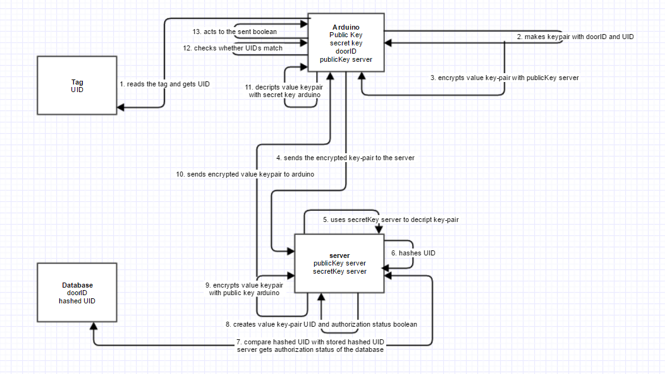

This system uses different blocks. Information goes from the tag to the arduino, from the arduino to the server, from the server to the database, from the database to the server and from the server to the arduino. Here is described what happens at which block.

**Arduino**When the tag is presented to the arduino, the arduino reads its UID. The arduino makes a value key pair with its own door ID and the read UID. This key-pair is encrypted using the server’s public key. The arduino now sends this secured value key pair to the server.

**Server**The server gets the encrypted value key pair and uses its secret key to decrypt it. Then the server hashes the UID. The server now compares the hashed UID with the hashed UID in the database and gets the authorization status of the key (as a boolean). The server creates a value key pair with the UID and the boolean value. The server uses the public key of the arduino to encrypt this new value key pair. This secured key pair is now send to the original arduino.

**Arduino**The arduino gets the secured key pair (with UID and boolean value) from the server and decrypts it using the private key of the arduino. The arduino checks if the original sent UID is equal to the just received UID and handles in regards to the boolean value stored in the value key pair. True will result the door to open and False will give a negative feedback.

**2.3 Use**

When the card reader is out of use it will show a solid red light.

To use the card reader, first the user holds their personal key card the RFID reader. The RFID reader will then read out the user’s personal ID, where the server then compares this with the ID’s which are authorized to enter the area which lies behind the specific door.

If the card is successfully read then a signal will be sent which then outputs an audio; namely a single beep.

If the person is authorized to enter a certain area, this will be confirmed by a long beep and a green light. While this beep lasts the door is unlocked and can be opened, if the door is not opened after the sound has ended the door will lock itself again. If the is opened by the user this will lock again when the door is closed. When the door is closed the light will turn red again.

If the person is not authorized to enter a certain area, this will be confirmed by two short beeps; in this instance the light does not change. The door will not be unlocked.

**3. Evaluation**

At this point in time, the evaluation is still empty. This because the project is being worked on and since it’s not built yet there is no way to evaluate on it.

**3.1 Overview**

**3.2 Prototype**

**3.3 Testing and Results**

**3.4 Assessment**

**3.5 Next steps**

**Appendices**

**References**